

**East West University**

**Project Report**

**Course Title:** Web Programming

**Course Code:** CSE479

**Section:** 03

**Submitted by:**

| **Name** | **Id** |
| --- | --- |
| Khadija Akter Meghla | 2022-1-60-256 |
| Kamrun Nahar | 2022-1-60-301 |
| Jannatul Ferdaus | 2022-1-60-377 |

**Submitted to:**

Md. Arman Hossain

Lecturer, Department of Computer Science and Engineering

**Date of Submission:** 17 May, 2025

**Introduction**

The E-book website is created to save the users time and energy which they needed to get the pdf and to read online from the internet. The e-book website helps the users to find their desired book on a single site, and they also can search the book from that site. There have many e-books website which provided users this book reading facility by paying fees. The users need to provide fees to read the single book from the site.

The website where information is often locked behind the pay walls and subscriptions, several e-book platforms are breaking that barrier –offering free and open access to literature, academic texts, and rare historical works. Our websites are not only legal and accessible but also driven by the noble mission of sharing knowledge with everyone, regardless of economic background. The e-book website we created contains the facility to read the book online and download the pdf version of the book without paying any fees.

**The future scopes** we want to create for the users, the users who want to publish their heart contents as book shapes; the user can publish their books through our e-book platform. Also, we want to create the scope for the users to read the book which they need to pay the fees for the book from a one-month subscription process.

**System Features**

1. **Home page Overview**

The home page is designed for the guest, users, and admin. The guest user can read the book from the online. The home page containing the feature of book search features, shelf features, profile features, recommended books features, more books features, and the bottom navigations bar containing home page, shelf page, trending page.

#### **Recommended Books**

**User**: The recommended books section works for registered users and displays books by rotating through different genres. The genres are determined based on the user’s previous searches. For example, if a user searches for a specific book, recommendations are generated based on the genre of that book.

**Guest**: Guests and new users see a different recommended books section, which displays a default set of books on the homepage.

**Admin**: When an admin logs in, the recommended books section displays all the books added by the admin.

#### **More**

The **More** buttons on the homepage redirects guest and users to the **Book Buckets** page, where all books are listed. This page is updated with any additions or deletions made by the admin. The admin, user, and guest can also search for books on this page using the book title.

### **Book Details**

After clicking on a book, the **Book Details** page displays the book’s cover image, title, and author name. Below the book, there are buttons for:

* Download PDF
* Add to Shelf
* Read Online
* Add to Wish list

The read online section is one of the best features of our website since the users, guest, and admin can read the books from online on the website. The user can download the pdf copy of the books, if they want they can add the books on their personalized shelf and also they can add the books to their wish list.

1. **Log-in:**

When a guest or unregistered user want to see shelf or profile which is shown when they browse the website first, the alert message shows to log-in. Then if a user went to log-in they need to provide their name, email, password, confirm password to registered their name as user then they can see the shelf and trending section.

1. **Trending:**

The trending section is works for every users and guest. The trending function we designed as a book is read thousands times in every single minutes by the users and guest, that book place on the trending section. The books of the trending section will be disappeared after 24 hours. The guest and user can go Book Details page.

1. **User:**

**User Overview:** The user after finishing their registration process, they can now log-in by putting their email and password. We provided various facilities for the users, after log-in the user can see their profile contain history, wish list, edit profile, log-out buttons.

**History:** The users’ history sections contain the book they read, if the user read a book multiple times then that also shows on the history sections. The user can also read the book from the history by clicking on that book.

**Wish list:** The book can save as wish list section if a user wants to read the book later. From the wish list section the user can easily fetch the book which they eagerly wanted to read however due to shortage of time they could not able to read the book. The read online button on the every book of the wish list is helps to read the book online on the app whenever they want to read.

**Edit Profile:** The user can make their profile personalized as they can have the opportunity to change their user name and profile picture. The changes take place without any prior authentication that means the changes do not need any requirements. The log-in user can easily change their user name and profile picture whenever they want.

**Add to Shelf:** The shelf facility is only for the users, they can add book on the shelf by clicking “add to shelf” from book details. They can use shelf as their personal library where they can place their personal favorite books to the shelf. After adding the book on the shelf then read button shows on every book on shelf.

1. **Admin:**

Admin Overview: The admin when log-in the profile it shows the admin dashboard which contains:

* Home,
* Add Book,
* Delete Book
* User Overview.

Add book: The admin can add book by putting book id, book name, author name, genre, book image, book pdf. The added book then shows on the Book Bucket lists.

Delete Book: The admin can delete a book by using the book id.

User Overview: The admin have access to see the activity of the user. The users whom are log-in, the admin can track the user activity like their active status (blocked or active), the number of books they place on the shelf, wish list. The admin also can see the registered date of the users. The admin can block and unblock a user if they want. The blocked user is unable to have access of any user facilities.

**Guest Overview**

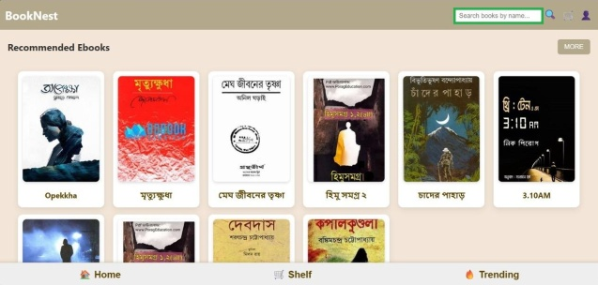 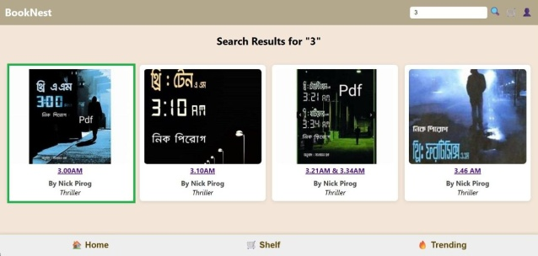

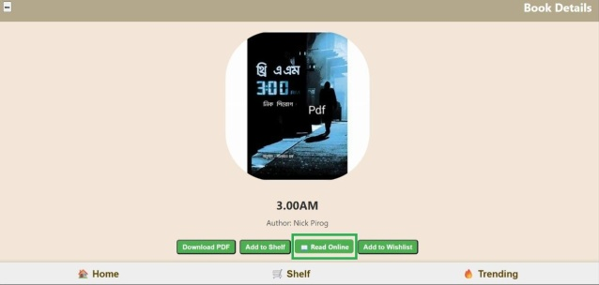 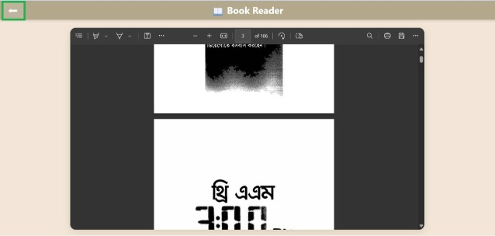

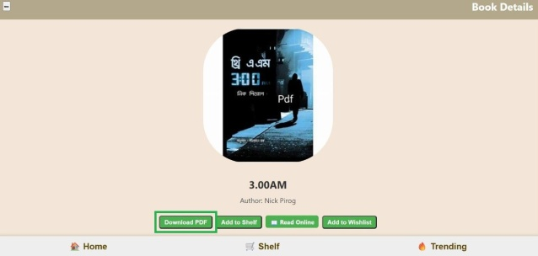 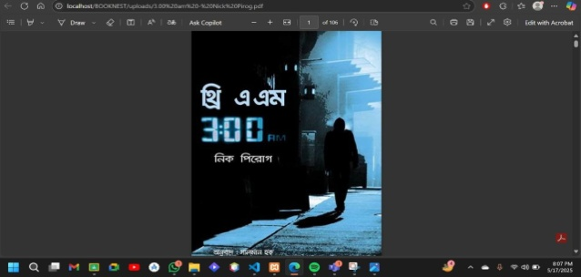

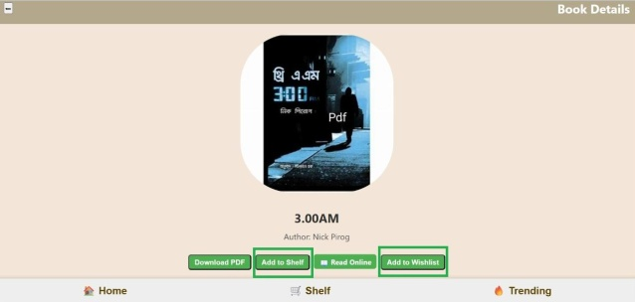 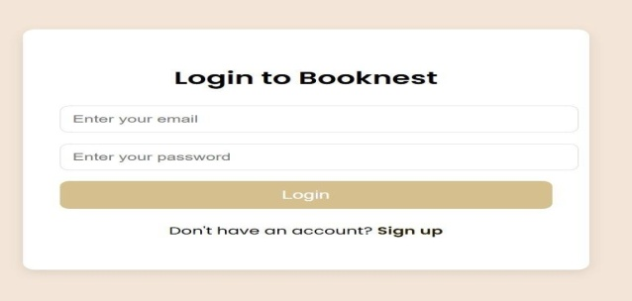

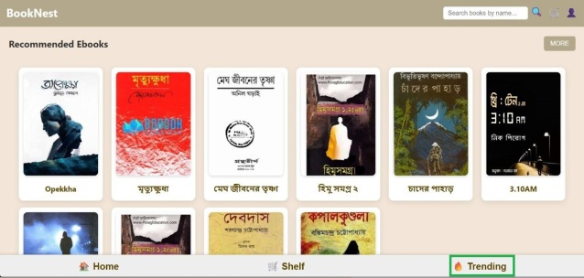 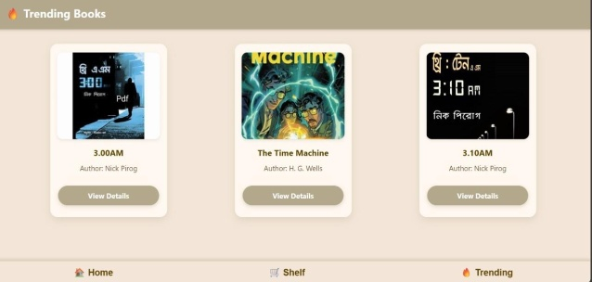

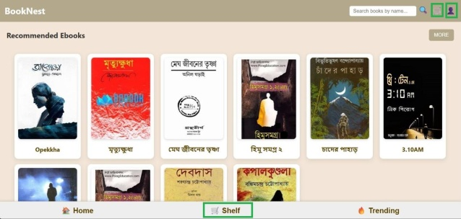 

**User Overview**

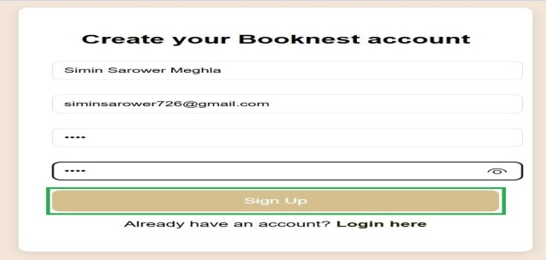 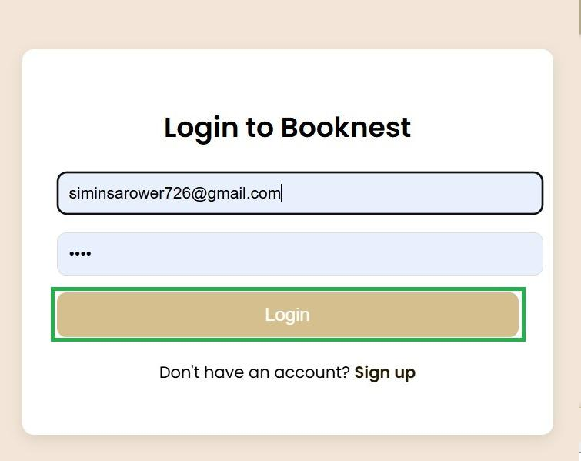

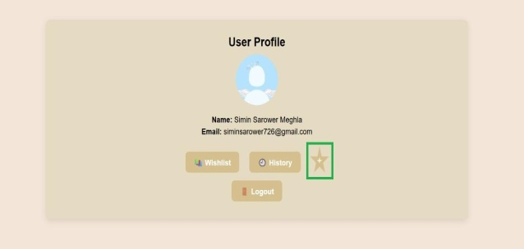 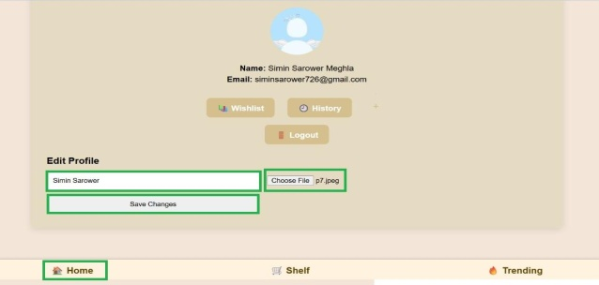

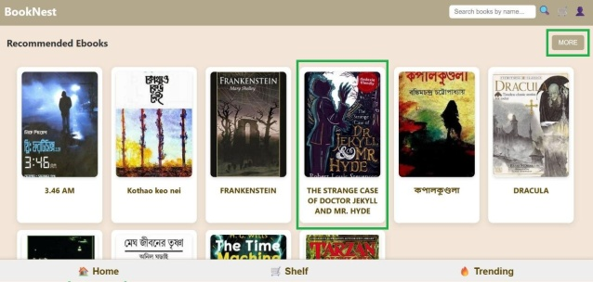 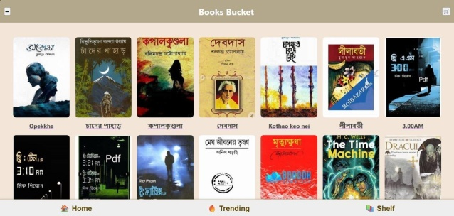

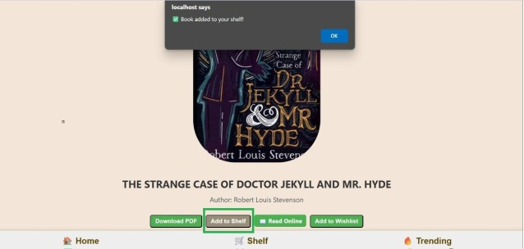 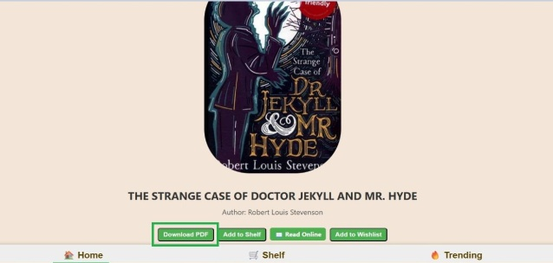

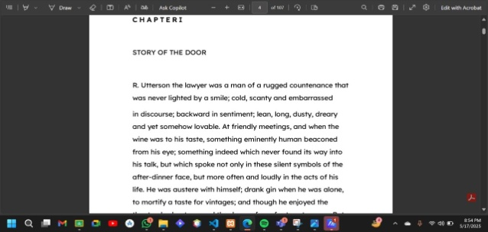 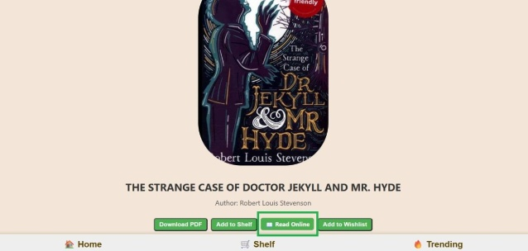

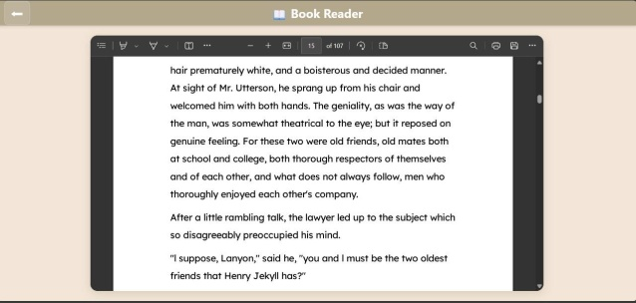 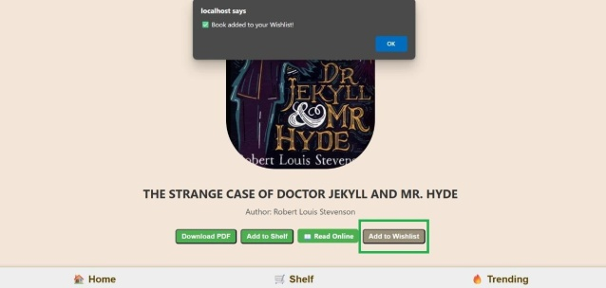

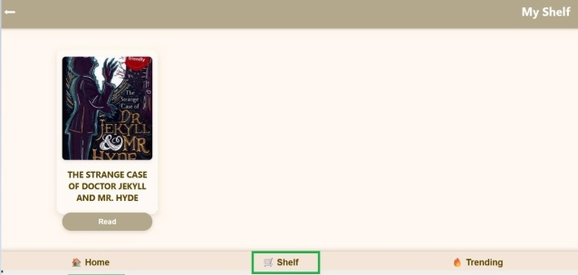 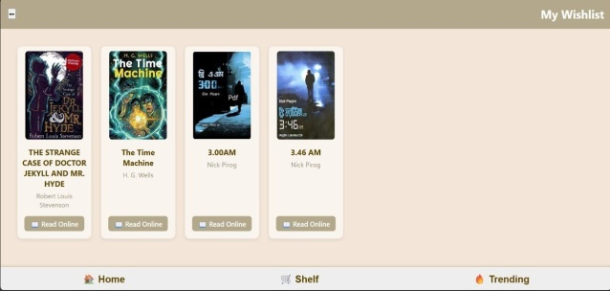

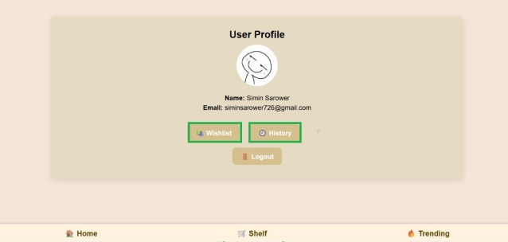 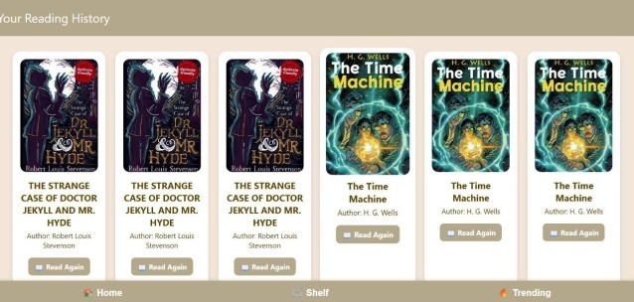

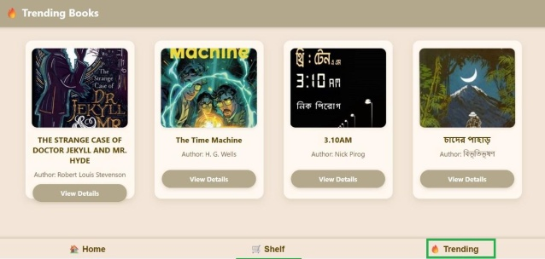 

**Admin Overview**

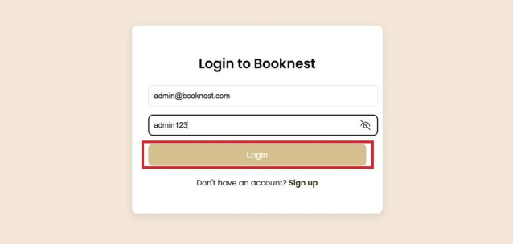 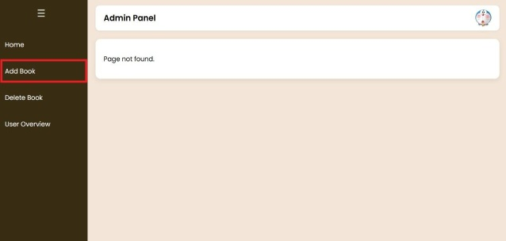

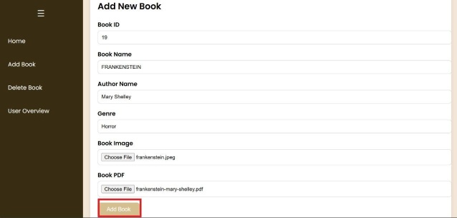 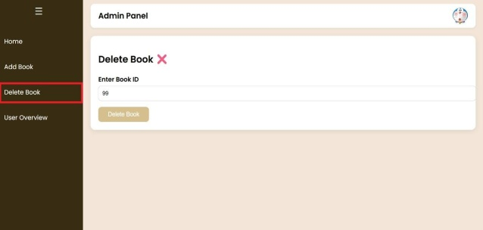

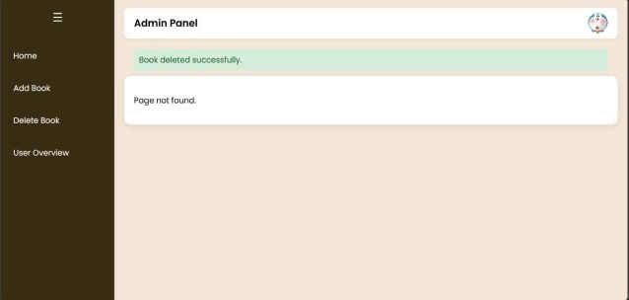 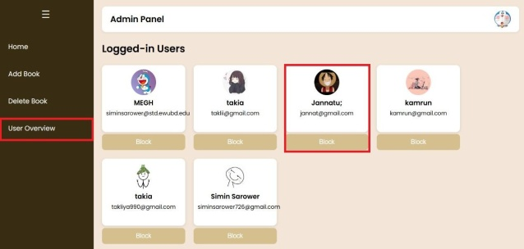

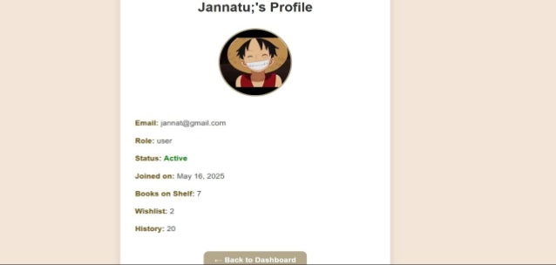 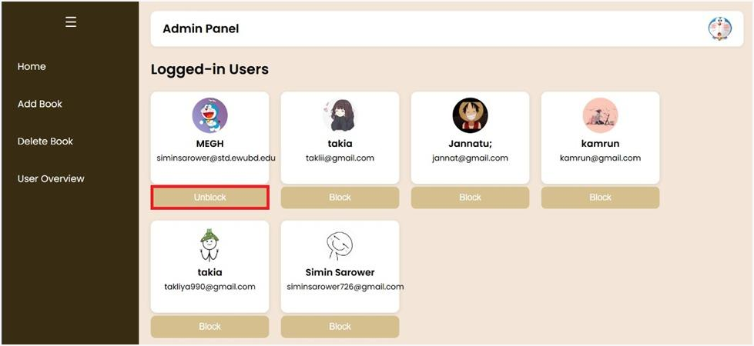

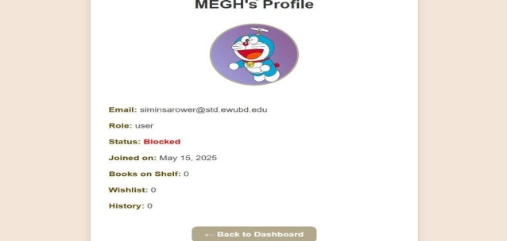 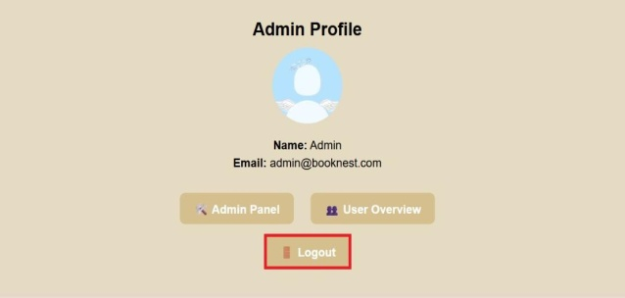

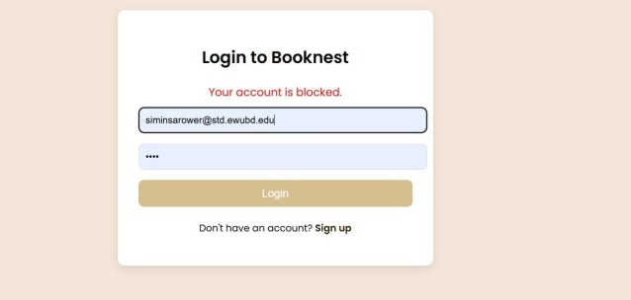

**Database**